Anne Lesley Caddick
Reception into Church
Wednesday 21st December 2005

The priest leads the procession into church, reading the sentences from scripture, to the anthem “I was glad when they said unto me, let us go into the house of the Lord”.

Please stand until Anne’s family have taken their place, then sit or kneel for the service.

Introduction and opening words

Priest: In the name of the Father, and of the Son, and of the Holy Spirit. Amen

We receive the body of our sister Anne with confidence in God, the giver of life, who raised our Lord Jesus from the dead.

Sprinkling the coffin with water.

The coffin is sprinkled with holy water taken from the font. It is a reminder of baptism and the promise of eternal life that flows from it.

Priest: With this water we call to mind Anne’s baptism. As Christ went through the deep waters of death for us, so may he bring us to the fullness of resurrection life with Anne and all the redeemed.

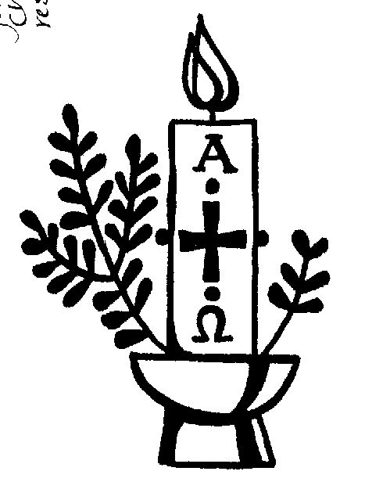
The Paschal Candle is lit to remind us of our Lord’s victory over the power of death.

Priest: Jesus Christ is the light of the world
All: a light no darkness can quench

Priest: Stay with us, Lord, for it is evening:
All: and the day is almost over

Priest: Even the darkness is not dark for you:
All: and the night shines like day

Priest: Let your light scatter the darkness:
All: and fill your church with your glory
A reading from the letter to the Romans (verses from chapter 8)

I consider that our present sufferings are not worth comparing with the glory that will be revealed in us. If God is for us, who can be against us? He who did not spare his own Son, but gave him up for us all – how will he not also, along with him, graciously give us all things? Who will bring any charge against those whom God has chosen? It is God who justifies. Who is he that condemns? Christ Jesus, who died – more than that, who was raised to life – is at the right hand of God and is also interceding for us. Who shall separate us from the love of Christ? Shall trouble or hardship or persecution or famine or nakedness or danger or sword? No, in all these things we are more than conquerors through him who loved us. For I am convinced that neither death nor life, neither angels nor principalities nor powers, neither the present nor the future, neither height nor depth, nor anything else in all creation, will be able to separate us from the love of God that is in Christ Jesus our Lord.

This is the word of the Lord
All: Thanks be to God

Verses from Psalm 27

All say together:
1. The Lord is my light and my salvation
whom then shall I fear?
the Lord is the stronghold of my life
of whom shall I be afraid?

4. One thing I have asked from the Lord which I will require
that I may dwell in the house of the Lord
all the days of my life

5. to see the fair beauty of the Lord:
and to seek his will in the temple.

6. For he will hide me under his shelter in the day of trouble
and conceal me in the shadow of his tent
and set me high upon a rock.

8. And I will offer sacrifices in his sanctuary with exultation:
I will sing, I will sing praises to the Lord.

Glory to the Father and to the Son:
and to the Holy Spirit:
As it was in the beginning is now:
and shall be for ever. Amen

The Prayers

Priest: Let us pray:

Prayers for Anne, her family and friends follow.

The Lord’s Prayer:

Priest: Let us pray for the coming of the Kingdom in the words our Saviour gave us:
All: Our Father, who art in heaven,
hallowed be thy name,
Thy kingdom come, thy will be done,
on earth, as it is in heaven.
Give us this day our daily bread,
and forgive us our trespasses,
as we forgive those who trespass against us.
And lead us not into temptation,
but deliver us from evil.

For thine is the kingdom,
the power and the glory,
for ever and ever. Amen.

Hymn During the hymn, a pall is spread over the coffin. Please remain kneeling to either listen or join in with:

The day thou gavest, Lord, is ended,
the darkness falls at thy behest;
to thee our morning hymns ascended,
thy praise shall sanctify our rest.

We thank that thy Church unsleeping,
while earth rolls onward into light,
through all the world her watch is keeping,
and rests not now by day nor night.

As o'er each continent and island
the dawn leads on another day,
the voice of prayer is never silent,
nor dies the strain of praise away.
The sun that bids us rest is waking -
our brethren 'neath the western sky,
and hour by hour fresh lips are making -
thy wondrous doings heard on high.

So be it, Lord; thy throne shall never,
like earth's proud empires, pass away;
thy kingdom stands, and grows for ever,
till all thy creatures own thy sway.

Priest: Let us pray:

We are already God’s children, but what we shall be has not yet been revealed. Yet we know that when Christ appears we shall be like him, for we shall see him as he is.

Keep watch, dear Lord, with those who work, or watch, or weep this night, and give your angels charge over those who sleep. Enfold in your loving arms our sister Anne who now rests in your eternal peace, and give her rest, this night and always. Amen

Rest eternal grant unto her O Lord
All: And let light perpetual shine upon her. Amen

Priest: May Christ, who out of defeat
brings new hope and a new future,
fill you with his light, his love and his new life;
and the blessing of God almighty
the Father, the Son and the Holy Spirit,
be with you tonight and always. Amen

